***This is a customizable template that provides an outline of the Building Insights through Observation Model***

**Topic or Essential Question:**

**Learning Objectives:**

**Materials:**

* (optional) Tablets for students with SOS Explorer mobile app installed
* Projector or display for teacher
* Art image
* SOSx dataset
* Sticky notes/easel/blackboard or digital space for recording questions
* Long strips of cardstock paper approximately 10 inches long by 2 inches across so you can have 5 squares of 2 in x 2 in (dimensions and shape can be changed based on your circumstances/resources/space). [Template](https://drive.google.com/file/d/1BFU2e18O64PeODqvRHLu3OsJXAM9Jcaq/view?usp=sharing)
* String and clothespins or tape
* Scissors, markers, pencils, glue, old magazines, erasers
* Rulers
* Paper clips
* Scratch paper
* 11" x 17" vellum tracing paper
* Handouts:
  + Local to Global/Fencepost Student Worksheet
  + [Design Tools Guide](https://drive.google.com/file/d/1iSIT_ZwXTVZm5UYeqeEcshZz-G6mkhDc/view?usp=sharing)
  + Map for Data Sketches
  + [Data Sketches Student Worksheet](https://drive.google.com/file/d/1BpCZ6eQK825bxpZqOvoUO2PEczZpai0l/view?usp=share_link)
  + 2 other global map datasets related to topic (print enough for groups)

[**Part 1 – Observation and Discussion:**](https://docs.google.com/document/d/1yW_d2kvTauB332gMe2CgDVcadQwQVK7R/edit?usp=sharing&ouid=118221842517100021754&rtpof=true&sd=true)

1. Find an art image and a mapped dataset that relate to the same topic.
2. Project the selected artwork so that it’s visible to the entire class.
3. Invite students to observe the image silently for 1 min.
4. Have students journal or write down initial ideas for 1 min.
5. Tell students: “*Let’s take a moment to look at this picture together*.”
6. Invite as many students as possible to share their ideas about what the image shows, using the following prompts/facilitation sequence (10-15 minutes)
   1. Invite Student Ideas: *What’s going on in this image*?
   2. Gesture: As each student is speaking, use your hand, mouse, or pointer to gesture to parts of the image that they are referencing so that the whole class can see.
   3. Paraphrase: Repeat the student’s observations using different language, taking advantage of opportunities to introduce appropriate vocabulary and without validating/invalidating their ideas.
   4. Ask for Evidence: *What do you see that makes you say* ________ ?
   5. Invite More Ideas: *What more can we find*?
7. Thank the class for participating in the experience and for sharing their observations.
8. (optional) Have students share in pairs any additional thoughts or observations (5 minutes): “*Now that we have all looked together, I know there are still more ideas. Turn to a person sitting next to you and share more or share something you didn't share with the larger group.*”
9. Tell students that now you are going to use the same approach and observe a mapped dataset. *It is important you do these VTS sessions back to back. The VTS with art image may be more accessible to many students and encourages those that do not usually speak up or that are uncomfortable with science/data to participate. The art image may be more engaging and personally relevant, getting the students primed in the approach of observing and talking.
10. Project a mapped dataset (2D flat map) without the legend. Ask for 1 minute of silent observation time and (optional) 1 minute journaling time. [INSERT IMAGE]
11. Invite as many students as possible to share their ideas about the visual patterns they see in the data visualization, using the following facilitation sequence and prompts (~5 minutes)
    1. Invite Student Ideas: *What’s going on in this image*?
    2. Gesture: As each student is speaking, use your hand, mouse, or pointer to gesture to parts of the visualization that they are referencing so that the whole class can see.
    3. Paraphrase: Repeat the student’s observations using different language, taking advantage of opportunities to introduce appropriate vocabulary related to the phenomenon, visualization, and/or data (e.g., scale, hemisphere, latitude/longitude, trend, variability) and without validating/invalidating their ideas.
    4. Ask for Evidence: *What do you see that makes you say* ________ ?
    5. Invite More Ideas: *What more can we find*?
12. Project the mapped dataset WITH the legend now, so that it’s visible to the entire class.
13. Invite students to look again at the data visualization that now includes a legend, providing ~1 minute to silently and independently observe.
14. Invite as many students as possible to share their ideas about the visual patterns they see in the data visualization, using the following facilitation sequence and prompts (~5 minutes)
    1. Invite Student Ideas: Now that you see this addition, how has your thinking changed?
    2. Gesture: As each student is speaking, use your hand, mouse, or pointer to gesture to parts of the visualization that they are referencing so that the whole class can see.
    3. Paraphrase: Repeat the student’s observations using different language, taking advantage of opportunities to introduce appropriate vocabulary related to the phenomenon, visualization, and/or data (e.g., scale, hemisphere, latitude/longitude, trend, variability) and without validating/invalidating their ideas.
    4. Ask for Evidence: What do you see that makes you say ________ ?
    5. Probe for more: What do you think [visual feature you observed] might mean?
    6. Invite More Ideas: What more can we find?
    7. If students are having difficulty providing new observations, try asking:
       1. What do you wonder?
       2. What jumps out at you? What do you see first?
       3. Does anything in this visualization seem unusual or unexpected to you?
       4. What’s interesting to you? What is familiar to you?
       5. If you could talk to the scientists who made this, is there anything you’d want to ask them?
15. Thank the class for participating in the experience and for sharing their observations.
16. (optional) Have students share in pairs any additional thoughts or observations. Ask them to think about additional questions they have which you will record in the next section (~5 minutes)
17. Tell students: “*Now that we have all looked together I know there are still more ideas. Turn to a person sitting next to you and share more or share something you didn't share with the larger group. Think about additional questions you might have. We will discuss these questions next as a class.”*
18. Develop a list of questions that were generated and ask for more questions. Teachers should interject questions that would facilitate the investigation/learning of content if the students have not yet brought it up. Ask: *What are you curious about? What questions do we have? I’m curious why the patterns are XXXX.*
19. Create a digital (e.g., Google Docs) parking lot with a question list or use sticky notes, and tell students you will revisit these questions later in the program.

[**Part 2 - Local to Global/Fencepost:**](https://docs.google.com/document/d/1qAULVgV8XF-fzvn3Nur85-z5YXXlDAdZ/edit?usp=sharing&ouid=118221842517100021754&rtpof=true&sd=true)

1. Give each student the Design Tools Guide handout
2. Tell students: “*Data like we just saw in the VTS dataset exercise comes from a variety of sources – individuals can collect data at a local level or one point in time and then combine those observations/data to show data over time or over a larger spatial area. We can also collect data with satellites which provide large areas of remotely sensed observations and can even provide global pictures of data/science phenomena. People use symbols to convey information in a simple and effective way. Symbols are an important part of maps and can represent a range of different types of data. Symbols are described in a legend – a box or other place on the map where there is a key that says what each color of symbol means. Let’s look at different ways we can represent data.*”
3. Review the Design Tools Guide with students - ask the students to reflect on the previous activity observing maps about which design tools were used/chosen and why.
4. Give each student a strip of paper that is divided into 5 squares numbered 1 through 5. Hand out the survey questions. [Link or list survey questions] [See this guide for tips](https://docs.google.com/document/d/1E4rA9Dgg_u_lZa5mlj9xjLW0Q4tn1w5O/edit?usp=share_link&ouid=118221842517100021754&rtpof=true&sd=true) on creating questions.
5. Read through each question and discuss with the class what symbol they think would be best for each answer choice.
6. Have the students answer the questions on their strip using the colors/symbols that correspond to their answer choice. Instruct the students to work their way through the questionnaire and respond to the first question in the first block and so on. For some questions, students can color, draw or collage with images from the magazines. For other questions, a written word or phrase is ideal.
7. After all students have finished their responses, line all the students’ work side by side as a “fence post” (tape them on a wall or attach to a string) so that you can see trends across the class.
8. Invite the students to silently observe the ‘fence posts’ for 1 minute.
9. Invite discussion or written responses on the following:
   1. What patterns do you notice?
   2. What do the patterns tell us about our collected data?
   3. Do you think the patterns would be different in other locations/with other ages/more people?

[Optional activity - Data Visualization Choices](https://drive.google.com/file/d/1zoXj39pxH5UXZAV_AcdEvBXX_mO7mU6c/view?usp=share_link) - homework or in-class activity

[**Part 3 - Data Sketches**](https://docs.google.com/document/d/1KSoVD4xq6q4c2gScvpVs7FlNx1_k-_P0/edit?usp=sharing&ouid=118221842517100021754&rtpof=true&sd=true)**:**

Have students sit in groups of three.

**Part 1**

1. Give each student a printed copy of the original mapped data (with legend) from the VTS-SOS Session along with the “Design Tools” handout.   
   *Note: By now the students should be familiar with both the original map and the design tools. It is important to keep referring to the design tools card so students become familiar with using them.*
2. Explain: “Remember how we looked at the different mapped data representations and how we used the Design Tools to come up with our own symbols to answer the questions in the Fencepost Activity? Today we are going to discuss mapped data further and practice using these tools ourselves by creating our very own map legends with symbols, colors, marks…
3. First, let’s remind ourselves about our map from earlier in this lesson. *Invite discussion about the following questions regarding the printed map you have handed out* (10 minutes)*:*  
   1. What design tools were used to draw the data on this map?
   2. What is included in the legend?
   3. Why do you think they chose this particular design tool for this set of data?
   4. While some tools are better for representing sets of data, there is no right or wrong tool. Are there different design tools we could use to represent this data? *Look through the card and discuss what some good choices might be for this topic.*
4. Give each group two additional mapped datasets related to the topic so that each table of three students has a total of three maps to work with. Include the source of the data on each map. [INSERT IMAGES OF EACH OF THE MAPS IN YOUR SET]
5. Invite students to silently observe their maps for a few minutes. (5 min.)
6. Ask the students to decide within their group how they might represent the data in each of the three maps in a different way than it is currently while using three distinct design tools (ie. color, symbols, scale) from their Design Tools sheet for the three maps. Have students work on developing new legends for each map using scrap paper, pencils, and markers (10 minutes)
7. Ask each student to choose one of the maps. Hand out the “Data Sketches” student worksheet 1 and the map template.
8. Have students paperclip a sheet of tracing paper over the map template and follow the prompts on worksheet 1 (*please show an example of what they are being asked to do*). This worksheet will guide them through beginning their map. *The map template provided to be used as a guide under the tracing paper is important because it forces each student to create a map that is on the same scale as the others so that these maps can be easily layered together in the second part of this exercise. The order of steps on the worksheet is important to follow because it allows the student to create the legend prior to getting involved in the task of drawing. You, as the teacher, can walk through each step one at a time, if needed, or have the students follow the instructions independently. (10 minutes)*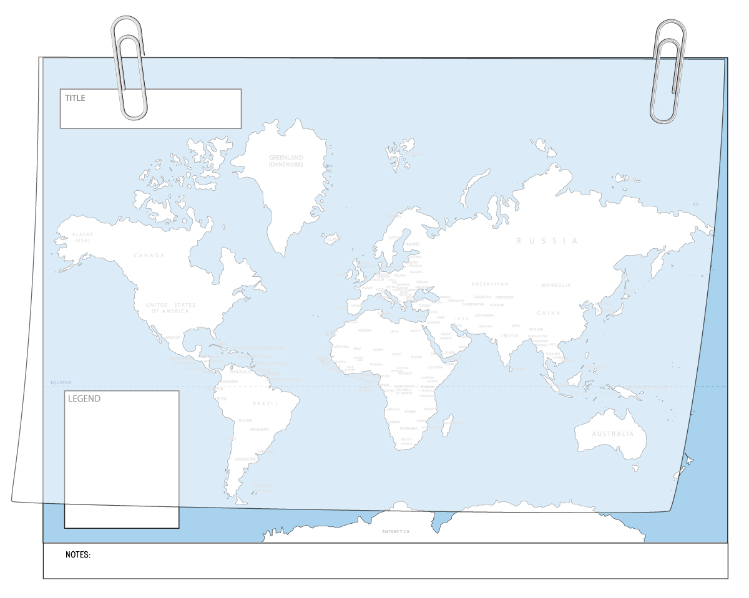
9. “Sketch” - the final task of this worksheet asks for the student to use their new legend as a guide to sketching out their mapped data in a new way. Students are also asked to note important features. *Students may begin by tracing the outline of the countries and, although it is not necessary and sometimes time- consuming, it is a way that they can begin to process the map spatially. For that reason, the timing of this component is variable and left up to the teacher. Students should have a minimum of 20 minutes to respond or the teacher may choose to break here and allow the students to complete their mapped “work of art” at home overnight and wrap up the next day with Part 2. (20 minutes – 2 hours)*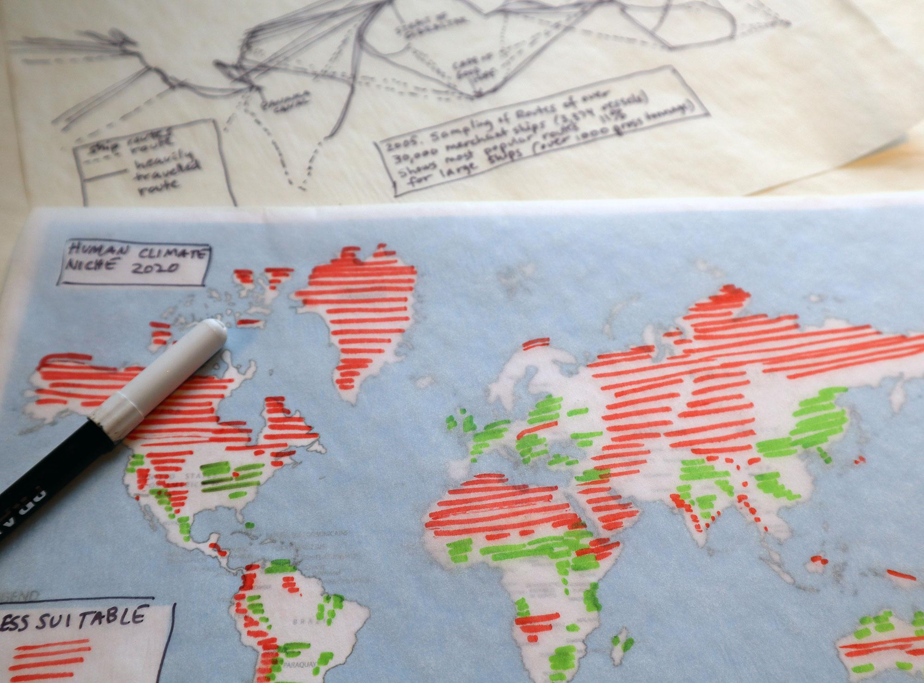

**Part 2**

1. Looking at the maps they have sketched, ask students to write a one or two sentence summary of what their sketched data represents and then answer the three following prompts (worksheet 2).

(10 minutes)

My sketch represents______________________________________________.

a. I see…

b. I wonder…

c. This data is interesting because…

1. Have the students share their answers with their group. (5 min.)
2. The group then works together to layer two maps at a time and look carefully at the paired maps, noting any patterns and correlations they can find and hypothesizing about what the correlations mean and giving each other feedback. (15 minutes)
3. Have students report out as a group to the rest of the class about their maps. Why did you choose that design tool? Was there anything interesting you discovered when you mapped the data? What correlations were you able to find when you layered your maps? What do these maps tell us about ______ (topic)? *Remember that in this exercise, the teacher can guide the discussion, correct the course, and introduce information about the topic as the lesson unfolds. (20 minutes or until your lesson is over).*

**Wrap-up:**

1. Revisit the questions generated (parking lot/sticky notes).
2. Discuss with the class the following questions:
   1. What questions did we answer?
   2. What questions remain?
   3. How can we find the answers to the remaining questions?
   4. What skills/tools have we learned that can help us answer them?
   5. What research can we do? What additional data do we need?

**Assessment plan:**

*We expect assessment will be individualized based on your classroom/students and these are just general questions for ideas.

Did student complete all activities?

Did student participate actively in discussion?

Did student show understanding of content?

Did student show critical thinking?

**Extension activities (optional):**

**Standards alignment:**

**Background materials/information for educators:**

**References:**